**Moustapha:**

I did the development of the Kivy based user interface and also did the hardware test for the temperature (with the temperature sensor), also reading humidity using the DHT11 sensor. All works

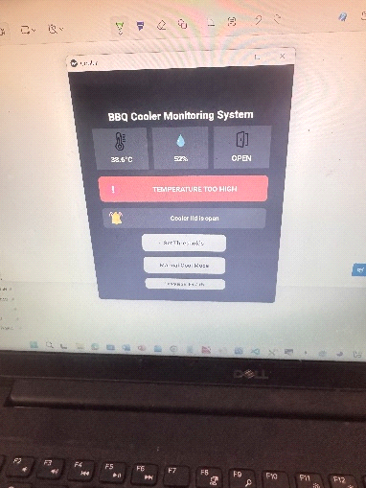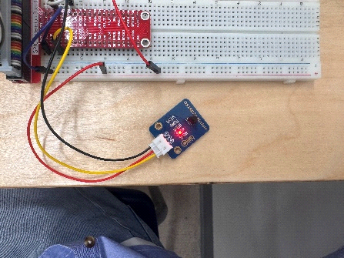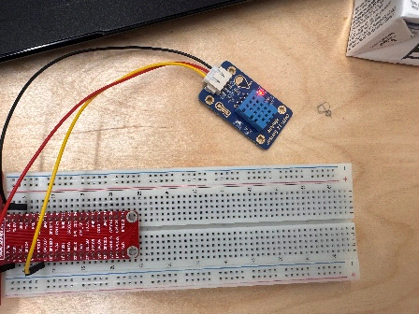

**Tarin:**

I used my teammates filesto test the hardware in order to read the contents of the sensors and update that data through MQTT in a DynamoDB table. To do that, I coded the files to create the connection and send the data. Then tested whether the data had been received in the AWS service, more precisely in the DynamoDB table.

**Sam:**

I created the hardware testing code for the led module, proximity sensor and active buzzer. I also updated the full wiring of the modules to accomadate for the DHT-11's updated wiring.

